**Table Structure View**

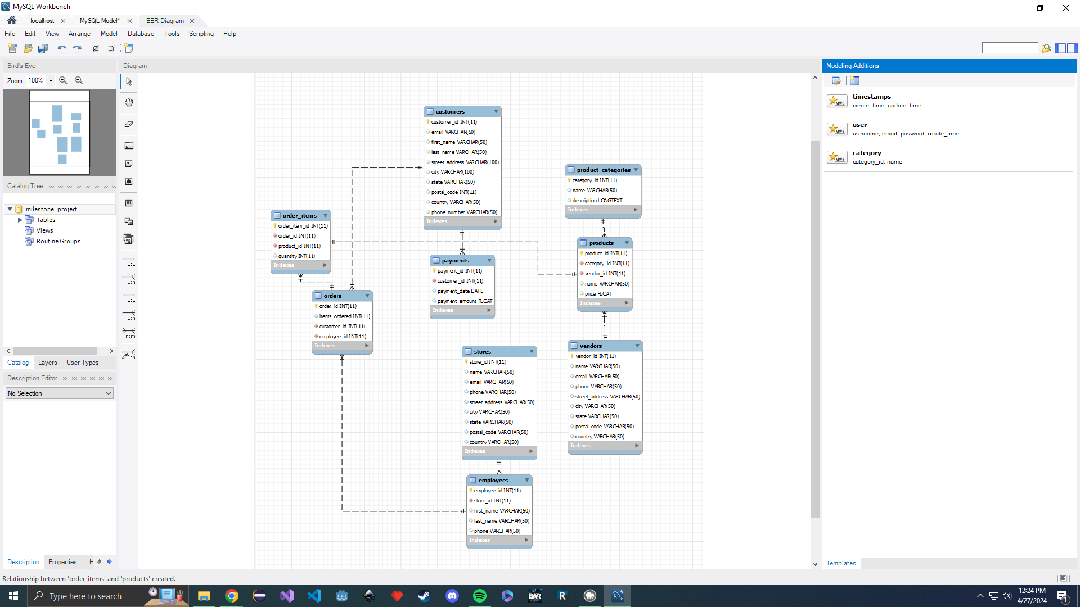

Shows the structure and relationships of tables

**Order Table View**

Shows the orders created for future queries

**Order Items Table View**

Shows the order items connected to the 2 orders

**Order Query**

Shows the code used to get required info for report. Only difference is I do not have a description field for products